Squirrel From HelL

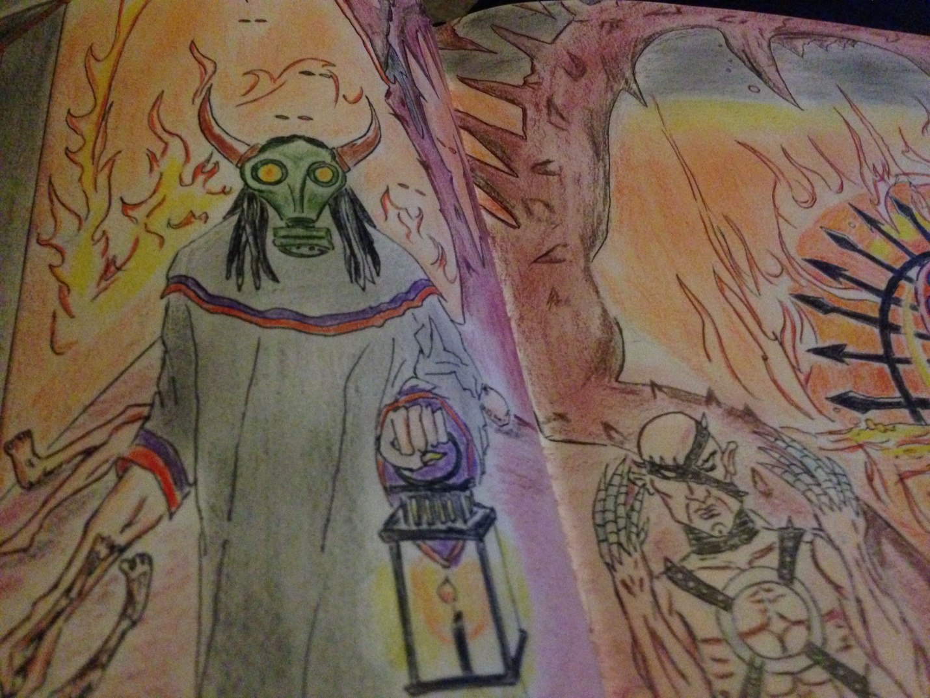

# Squirrel From Hell (Advanced Flash 2D Action Game)

Squirrel Hunger Games

Table of Contents

Table of Contents 1

2 Team Personnel

3 Target Audience

4 Visual Style 5

5 Story ……………………………………………………………………………………………………………………………………………………6

6 Characters 7

7 Game Mechanics 8

8 Controls 9

9 User Interface ………………………………………………………………………………………………………………………………………10

# 2. Team Personnel

Director and Programming Lead: Alexander Sanchez

Visual Artist : Alexander Sanchez

# 3. Target Audience

* General audience
* Video game fanatics and gamers
* Children ages 12 and up

4. Visual Style

The game will be developed as a traditional and nostalgic 2 Dimensional side-scrolling game featuring 2D original artwork.

5. Story (Nut A Good Time)

One gloriously bright summer day Suhugurim Squirrel and his lady squirrel friend Fiona were enjoying of the Sun’s rays and delights. As they skipped and they pranced merrily through the park a dark cloud distilled the skies and suddenly the furry pair were taken by fate when a gang of park critters known as the Rasputin Rascals suddenly appeared and the pair’s life took a turn for the worst. Suhugurim fought a tough battle but they were too many and he was left for dead with his friend taken without a trace and not a place to be found.

This time Suhugurim himself has reemerged from very pits of hells darkest in a mad frenzy to rescue his squirrel lady friend. He carries a weight colossal enough to take down an elephant. He will stop at nothing to restore justice and take back what they took from him.

He retraces his steps and goes back to where the only memory plaguing his mind takes him. To Lethe Park, the place he last recalls, the place where he was once slain.

# 6. Characters

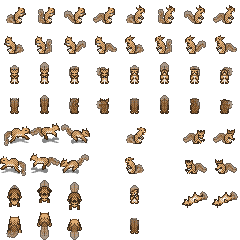



This name was found circled in an old Sumerian papyrus next to his body when he was first discovered that dark night in the catacombs, it read “Suhughurim“. He seems to respond to this name proclaimed Mr Dee. Nearest asserted translation in English declares this name means swift destroyer of souls and he is the fifty second physical incarnate specter of Marduk who owns his own soul until he’s met his goal. In our story our furry avenger faces a karmic combustion when he is deprived of his squirrel other half. Beat and left for dead in a park after a group of delinquent critters became his last memories. Now makes his return reanimated and recovering the squirrel of Doom made a pact with the red guy so that he may take back what was taken. He packs and loads all the weight he carries inside and takes to the streets in raging vendetta to rescue his woman and distribute some pain.

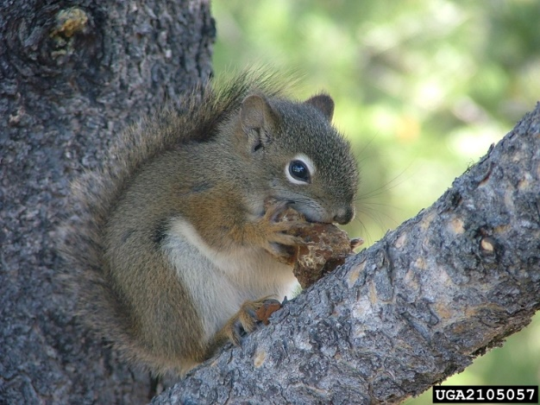

Princess Hecate : She is a squirrel princess and is the main characters other half. In our story she is taken captive by the Rasputin Rascals a ruthless and cunning crew from the lower underground world who are connected within the world’s largest illegal fur trade industry.

# 7. Game Mechanics

***Atmospheric Settings***

Each level will contain a 2 d background image to illustrate a different landscape in the game world.

This game will also have atmospheric and up beat electronic soundtrack to set the games dynamic moods.

***Game Play:***

The character traverses the world levels on foot using the directional buttons to move around in all directions of walkable areas as he pleases in a side scroll adventure game and avoids or defeats enemies along his journey by jumping on their heads or some form of demonic squirrel magic until he reaches the end of each level.

Each level contains a few enemies of 2 or 3 enemy classes and the difficulty progresses and the enemies are stronger as the game progresses.

A doorway to enter or a boss to defeat is placed at the end of the level to challenge our player and the next level is available if one of the two conditions have been met.

**Power Ups**

**Enemies**

**Level 1 Enemies**

Serpentine Joe : Common in most eerie parks of the game worlds unsettling districts.

Ruthless and sly these guys strike and bard their settlements causing serious health damage each time they bite. It is said that the prize for the hide after Serpentine Joe’s perished is 100 points, but the price of his bite attack is inflicting 10 percent of the current health bar.

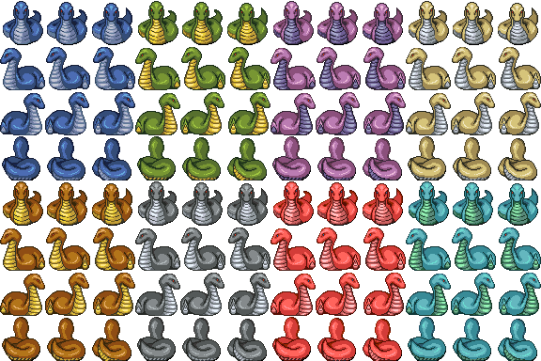

Cat-therine lv 1

Cats roam the streets and alley ways. They will always attack if they feel a threat or bother. Frisky and sleek they move with great speed and can inflict 5 percent health damage if a scratch is offered with collision to the player.

Defeating this frisky feline adds 50 points to the score.

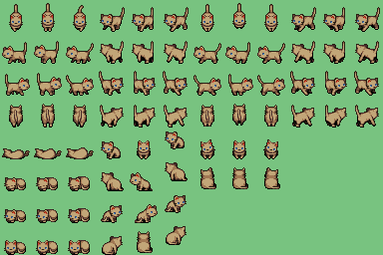

Level 1 Boss

Black Cat-Allack

He is the mystic alpha and ruler of the feline breeds. He is resistant to damage and require that the player can successfully execute 4 jumps and a magic attack is worth 2 jumps.

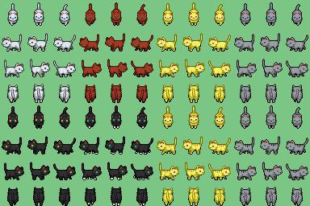

**Level 2 Enemies**

Cat-therine lv 2

She is at it again only this time she found time to hit the salons for a good scrub down and bleaching.

Level 2 Catherine’s possess all the same characteristics as her predecessors Lv1 Cat-therine’s only they are slightly faster and can inflict a bit more damage taking 6 percent of the player’s health bar with each scratch she asserts on the player.

Her fur is valued at 75 points to the player fur score.

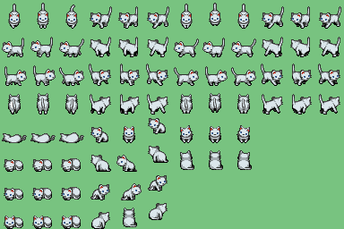

Blood Torso

Quite possibly the creepiest fiend in the druid woods. Found in alone or in groups they are resistant to damage and require that the player jump on their heads two times instead of one like

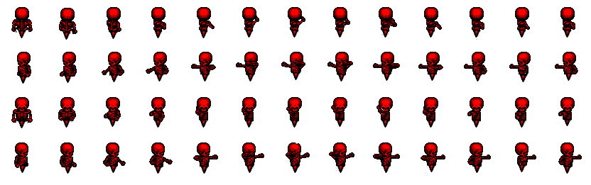

Level 1. Lethe Park

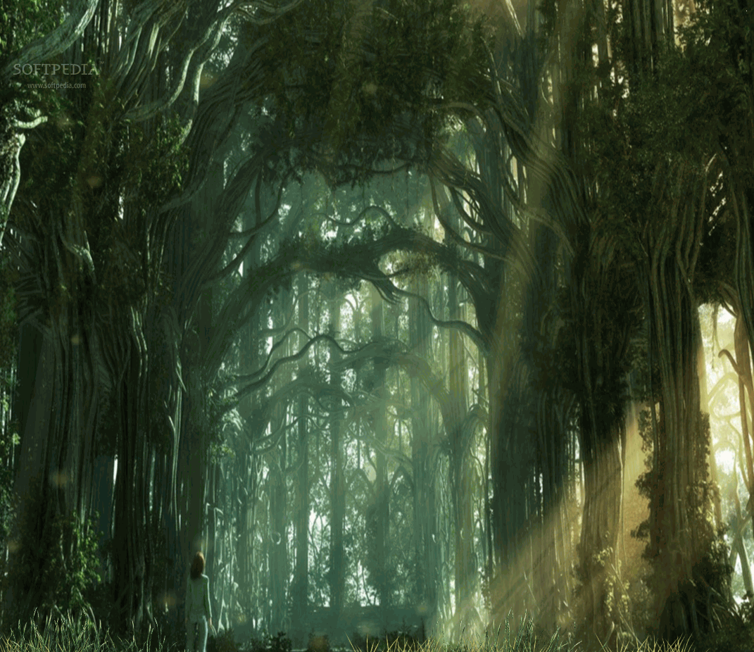

The player embarks on his first mission to find his beloved. Barely alive, lost and confounded the hero squirrel arrives at the forest are of the Park where he once died.

A haven for Serpentine Joe’s and Cat-herine’. Just a walk in the park this level.

At the end of the level there is a boss and a door.

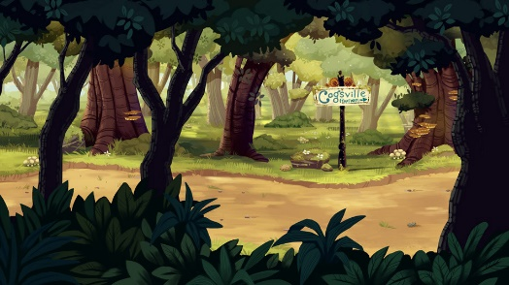

Level 2. Deep Delirium Forest (Final resting place)

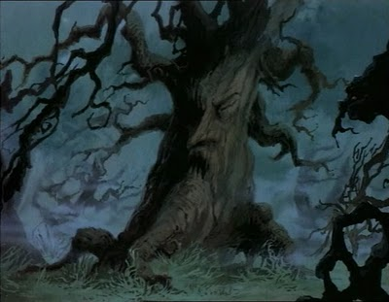

“The black doors I’ve found seem to be portals of not only space but definitely time and other dimensions.

Suhughurim has proven he is not messing around and has managed to attain a lead from a fallen enemy. He has made it to

Things are starting to intensify as our hero reaches this chapter of the story. There is a considerable raise in enemies and difficulty and the level is almost double in length of game play from the previous level.

Level 2 offers the player a challenge and an opportunity to fight higher level Cat-therines and Level 2 Serpentines, and most importantly it the first appearance of Blood Torso .

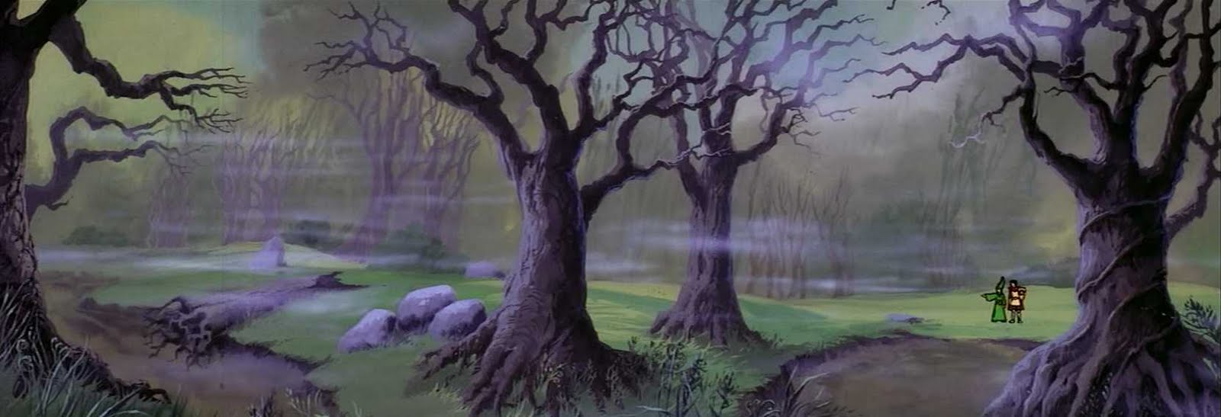

Level has sub level doors and a final door.

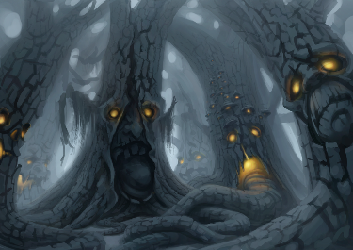

# 8. Movement and Controls

Forward Motion (Directional key Right or forward): The player is given no initial velocity.

WASD keys for directional movement.

W – up

A – left

S- down

D - right

Jump : Space Bar or J

Magic Attack : M

# 9. Main Menu and User Interface

Splash Screen

(Place Holder Art)

Program initializes with a splash screen that is set with a timer for two or three seconds and vanishes while transporting the player to the main menu.

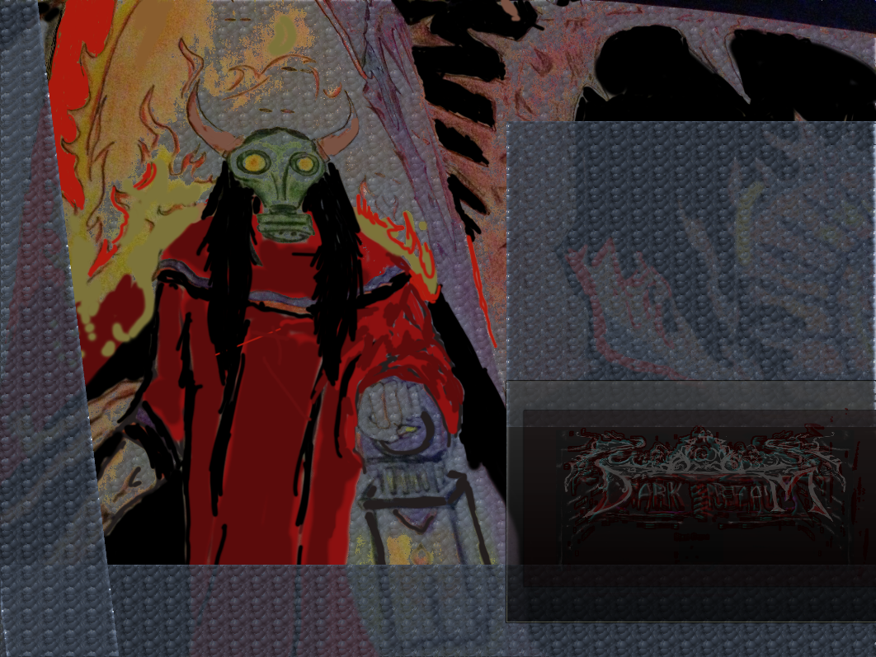

Main Menu

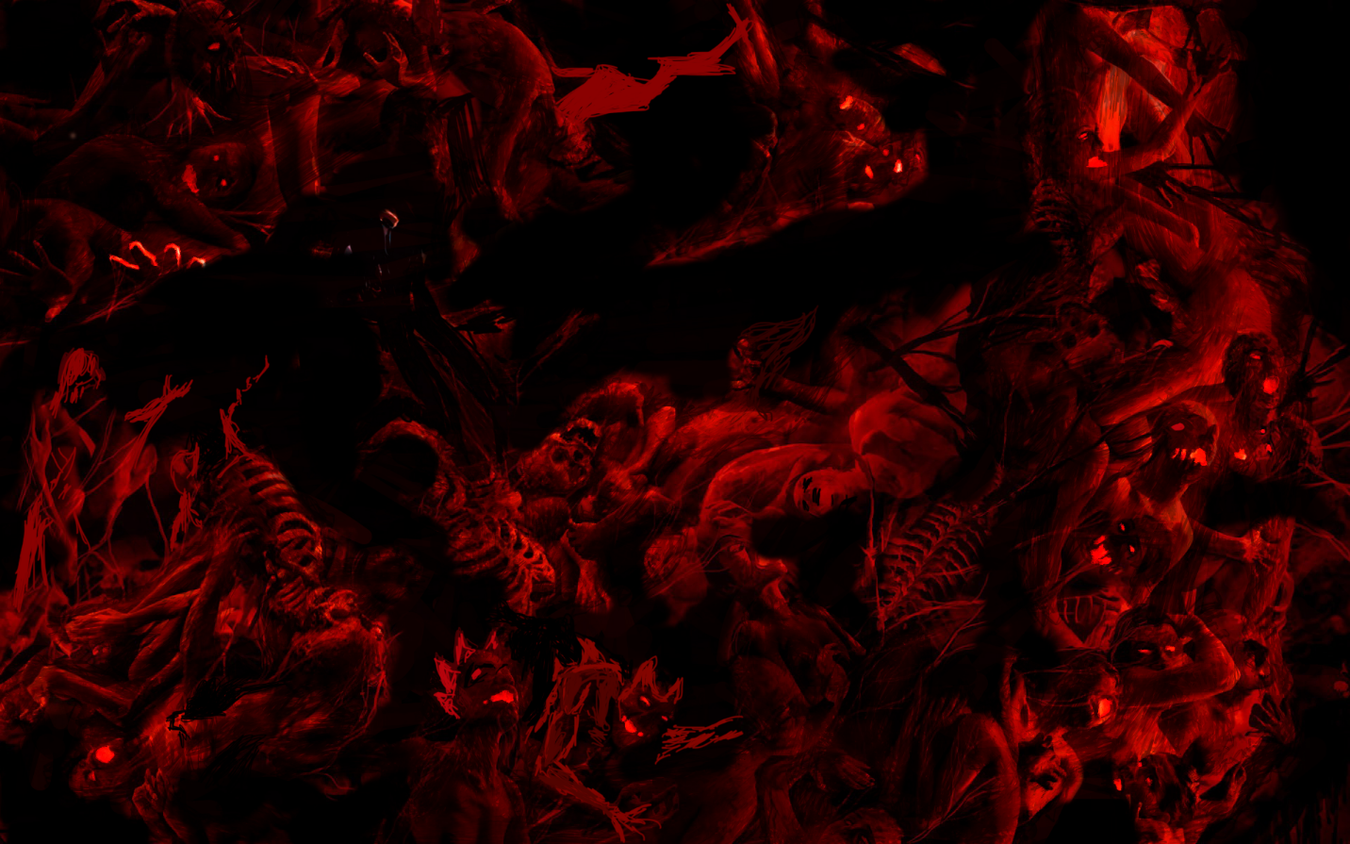

After the 2 second splash screen the game makes its vast greatness available through a main menu with three buttons. The first button (Start Game) is the portal to the game, the second (Quit Game) is an exit for the less courageous who would prefer to quit the game before attempting awesomeness and finally the third button (Credits) on the main screen is to transport the player to the developers credits page where artwork and artist and programmer credits are displayed.



Credits

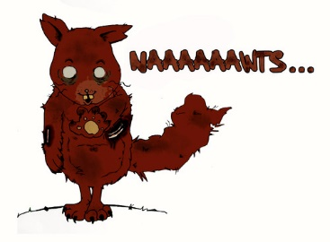

Player HUD (Heads UP Display)

Fur Score Text

The score is kept and incremented each time the player destroys and enemy

Health

The health is recorded on the screen while game is in active play mode and it will be displayed as a life bar or string with numbers to indicate the player’s current health.

Time

Time elapsing counting down to destruction.

Time will be set at a reasonable value relative to the length or crossing distance of the level as well as each levels own difficulty.

